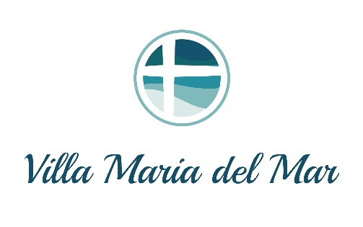

Villa Maria del Mar, located in Santa Cruz, CA, is a beautiful retreat center located on the bluffs overlooking Monterey Bay. The Sisters of the Holy Names welcome guests through the ministry of hospitality and serve a variety of individuals and groups, who are seeking a place for prayer, planning and healing. The Villa also serves as a Home for the Sisters of the Holy Names.

In order to foster wholeness and balance in mind, body and spirit for our guests, the Villa provides the following:

* Healthy, fresh food, including all day whole fruit and beverages. Salad bar at lunch and Dinner with hot entrée option, including vegetarian selection. ***Note: We are unable to accommodate individual meals for specific dietary requests. Guests with allergies or special dietary needs/practices must bring their own supplemental food.***
* A guest refrigerator and microwave are available for guest use in the dining room
* Quiet time is observed from 10:00pm-7:00am
* Guestroom check in is 4:00pm on day of arrival
* Guestroom checkout time is 9:30am *(guests may remain onsite through 2pm)*
* In your room, hand soap is provided and one set of towels per person. Please bring any additional toiletries, a hair dryer, beach towels, or any other items you may need.
* Note: Guestrooms do not have televisions or phones
* Complimentary WiFi and onsite parking are provided

Whilst onsite, we ask guests to please observe the following:

* Please keep noise to a minimum in the public areas, in consideration of other guests
* Please do not use cellphones in the dining room or Chapel
* No smoking is permitted in any of the buildings
* No lighted candles or open flames are permitted in guestrooms
* For the safety of our guests and staff, only registered guests are permitted onsite.

*Please contact our Reservations Manager if you would like to make arrangements for a visitor during your stay. Tel (831) 475-1236 ext. 10*

* Property access and guestroom keys are provided on arrival. Key security is the responsibility of all guests and we request the safe return of all keys upon departure. (Fee’s will apply for any lost keys)
* Guests onsite must be at least 21 years old
* Pets are not allowed; service animals are permitted with advance permission